AIR NEWZEALAND
Overview
This project demonstrates the concept of Object-Oriented Programming (OOP) in Python using inheritance.
It models a simple flight system with a parent class for general flight details and a child class for domestic flights with additional features.

Key Concepts Used
- Classes and Objects
- Constructors (__init__)
- Inheritance
- Method overriding (basic usage)
- super() function

Class Structure
1. Parent Class: general_flight
The parent class contains common flight details shared by all flights.
Attributes:
- flight_number
- origin
- destination
- arrival_time
- departure_time
Methods:
- display_flight() → Displays all basic flight details

2. Child Class: domestic_flight
This class inherits from general_flight and adds extra features specific to domestic flights.
Additional Attribute:
- baggage_allowance
Additional Method:
- display_baggage() → Displays baggage allowance

Class Diagram

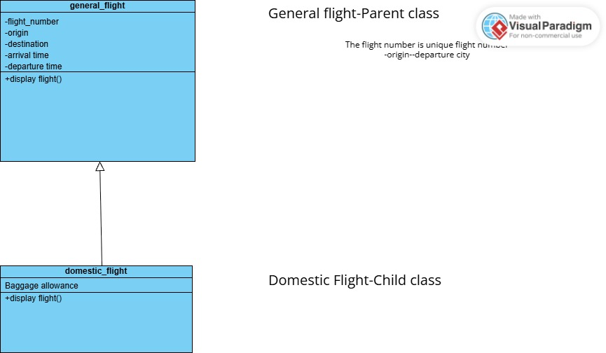

Column Name | Type | Description
flight_number | VARCHAR | Unique ID
origin | VARCHAR | Starting location
destination | VARCHAR | Ending location
arrival_time | TIME | Arrival time
departure_time | TIME | Departure time
baggage_allowance | INT | Only for domestic flights

